# [Microsoft](http://huskytech.uconn.edu/software/) Windows and Office 2019

## Overview

All UConn School of Business students and faculty are entitled to access [UConn School of Business's OnTheHub instance](https://e5.onthehub.com/WebStore/Security/SignIn.aspx?rurl=%2FWebStore%2FSecurity%2FSignIn.aspx%3Frurl%3D%252fWebStore%252fSupport%252fRequestCustomerSupport.aspx%253fsrc%253dRequestAnAccount%2526ws%253df1a3bccd-21c9-e511-9414-b8ca3a5db7a1%2526vsro%253d8%26ws%3Df1a3bccd-21c9-e511-9414-b8ca3a5db7a1%26vsro%3D8&ws=f1a3bccd-21c9-e511-9414-b8ca3a5db7a1&vsro=8) which provides access software resources such as Visual Studio Ultimate Edition, Windows Server Operating Systems, Visio, Project and more.

## Who is entitled

* UConn students enrolled in School of Business classes
* UConn School of Business faculty
* UConn School of Business staff

## Costs

There is no cost for this resource.

Go to <http://s.uconn.edu/imagine>

## Requesting an Account

Accounts for Imagine **do not authenticate with your NetID**. **Accounts are created by request only.** Students may request access for themselves and faculty/staff members may request access for their entire class/department/program/project/etc.

## How to request access as a student

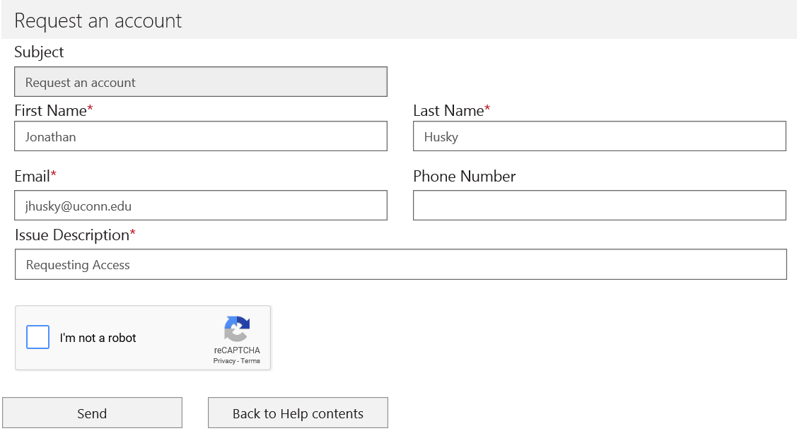

1. Visit the Request Access page '[s.uconn.edu/requestimagine](Go%20to%20http:/s.uconn.edu/requestimagine)' page and complete the form.
   1. Use your UConn email in the **Email** field
   2. Enter 'Requesting access' in the *Issue Description* field
2. You will receive an email confirming your request.
3. Within 24 business hours, you will receive an email confirming your account or requesting additional information.
4. You will receive an email with a link to complete your registration. Follow the link to set your password and login.

## Support

Visio and Project are NOT available for macOS. [Windows Learning Environment is required](https://confluence.uits.uconn.edu/confluence/display/BUSNIT/Windows+Learning+Environment).

If you have Office 2016 installed uninstall it before installing Office 2019, Visio 2019 or Project 2019. If you have Office 2016 installed use Project 2016 and Visio 2016. It is recommended that the 32-bit installers for Office, Visio and Publisher be used. **Please Note: Office 32 bit versions DO NOT work with 64 bit versions of Visio and Project, or vice versa.** See this page, [https://confluence.uconn.edu/display/BUSNIT/Installing+Project+and+Visio+from+Imagine+%28Formerly+Dreamspark%29+Premium](https://confluence.uconn.edu/display/BUSNIT/Installing+Project+and+Visio+from+Imagine+%28Formerly+Dreamspark%29+Premium%20) for details.

For assistance, please contact help@business.uconn.edu

## FAQ

Most common errors are caused when Visio and/or Project version do not match the Office suite version, see the support section above.

The second most common error is when Office 365 products are mixed with standalone products.

“You'll get this error message if you try to install an Office 365 product or a standalone Office 2013 or Office 2016 application (like Access, Visio, Project, Skype for Business, or OneDrive for Business) when you have the 2013 or 2016 versions of Microsoft Office Professional Plus or Microsoft Office Standard already installed on your computer.”

For details on “We found a problem!” please see this link <https://support.office.com/en-us/article/Office-installed-with-Click-to-Run-and-Windows-Installer-on-same-computer-isn-t-supported-30775ef4-fa77-4f47-98fb-c5826a6926cd>

## Installation Requirements

* Internet Connectivity
* Installation requires elevated or admin access. (Ability to install applications and write to the Window’s Registry.)

Click on the link for **Applications**.

Add the required software to the cart.

Check out.

Record the software’s activation key.

Download and install the software required for class.

** It is the student’s responsibility to download and install all required software, clients, plug-ins and other software listed on the professor’s syllabus. Some assistance and instructions may be provided **The University of Connecticut, School of Business does not provide long-term loaner laptops.**